
NTTDS Presents: “Set for Spring” (SFS) 2027
English Country Dance Weekend, April 9-11, 2027
Sokol Hall – Dallas, TX
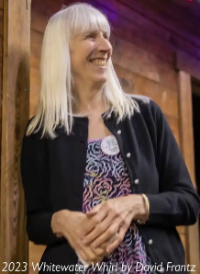
Caller Gaye Fifer

Gaye Fifer is an accomplished caller from Pittsburgh, PA. An active dancer herself, Gaye understands the subtleties of making dances particularly satisfying for dancers. Her instructions are clear and concise, as she is a teacher by profession. An easy smile and delightful sense of humor are part of Gaye’s relaxed, pleasant style at the microphone. Gaye calls contra and English dances throughout the US and Canada.

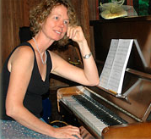 | Persons of Quality   | 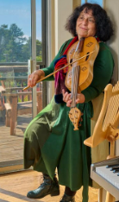
Rebecca King, Piano | Jim Oakden, Woodwinds | Shira Kammen, Violin
Rebecca King is a classically trained pianist with strong roots in Jazz and Folk Music. She is a sought – after musician for American Contra Dances and English Country Dances. | Jim is a dance musician, performing in a wide range of traditional and ethnic styles. He has been staff musician at major trad dance camps and has toured globally and throughout the US. | Shira Kammen received her degree in music from the University of California, Berkeley. She has performed and taught throughout the world for over 30 years.
NTTDS.org

